**TASK-01**

**Study the program and complete the table.**

**EXPLANATION:**

The program takes input from the user as “**VALUE_01”** after which it calculates the value of “**VALUE_03”** by the formula given in the task. At the end the program displays the values and their results in a table, using the same formula for specific values.

**INPUT:** 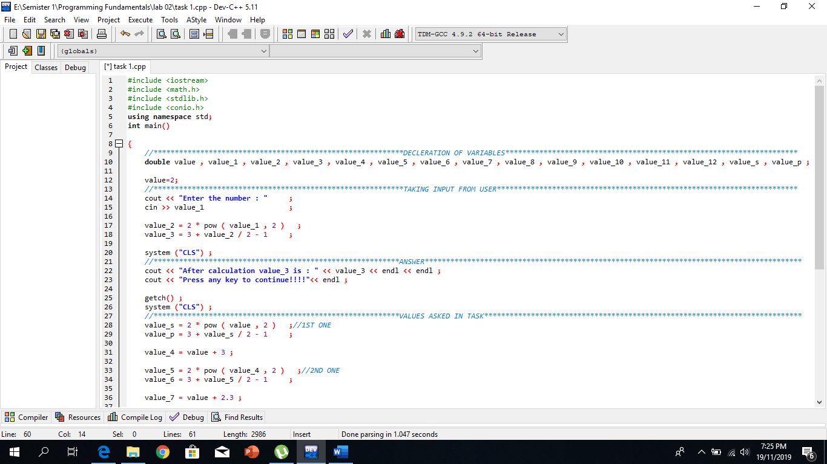

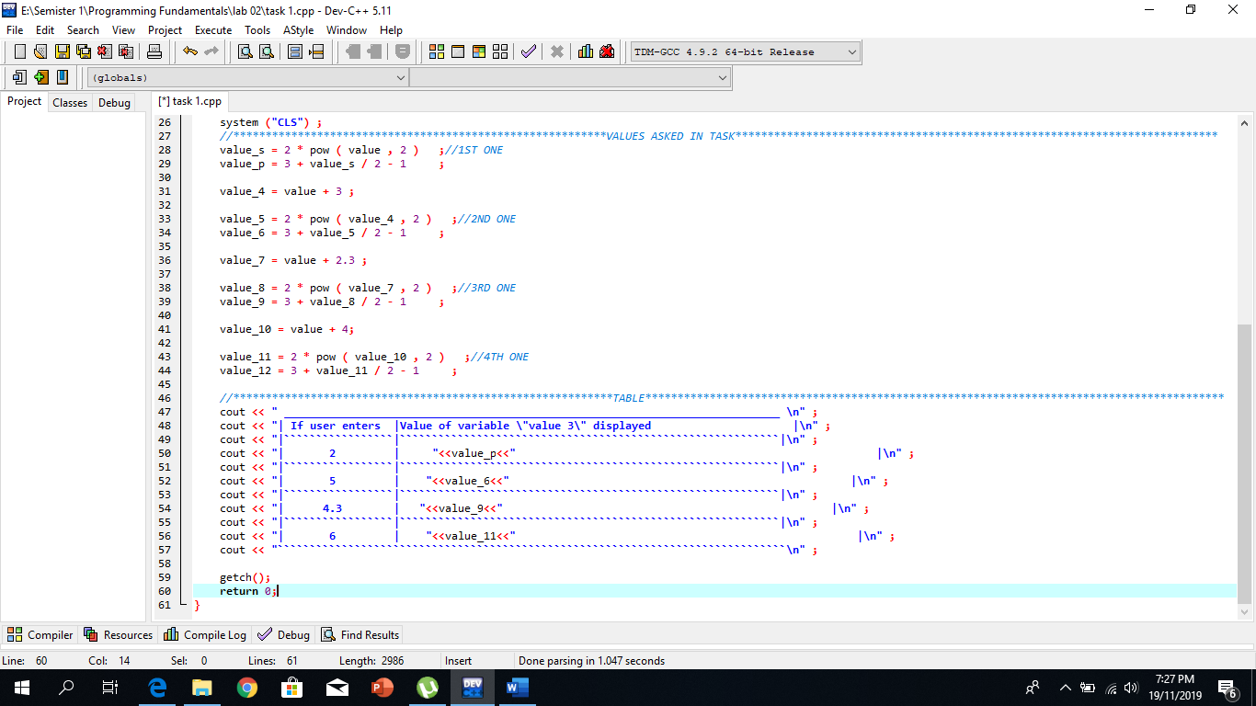

**OUTPUT:**

